**SATURDAY,   
JANUARY 11  
1 - 4pm YWCA York**

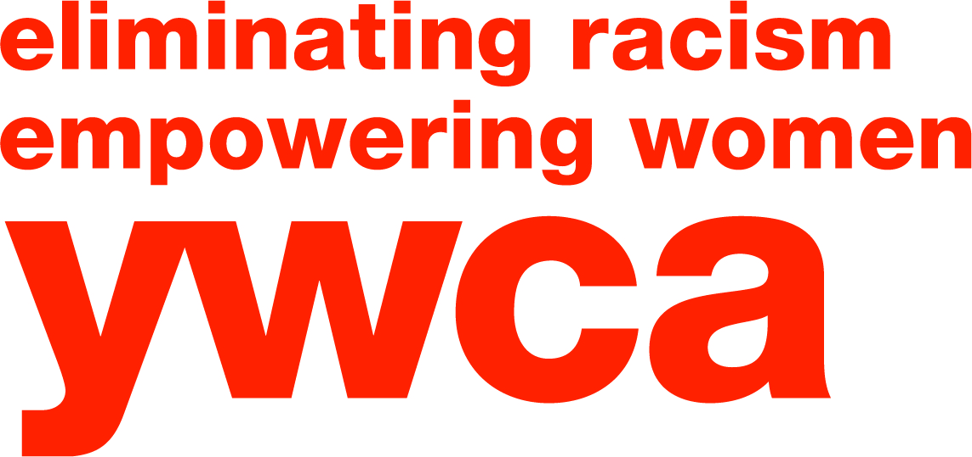

320 E. Market St. York, PA 17403  
*www.ywcayork.org*

Please register by calling 717-845-2631 ext. 4110   
or stopping by the   
YWCA front desk.

**FREE SYNCHRONIZED SWIMMING CLINIC**

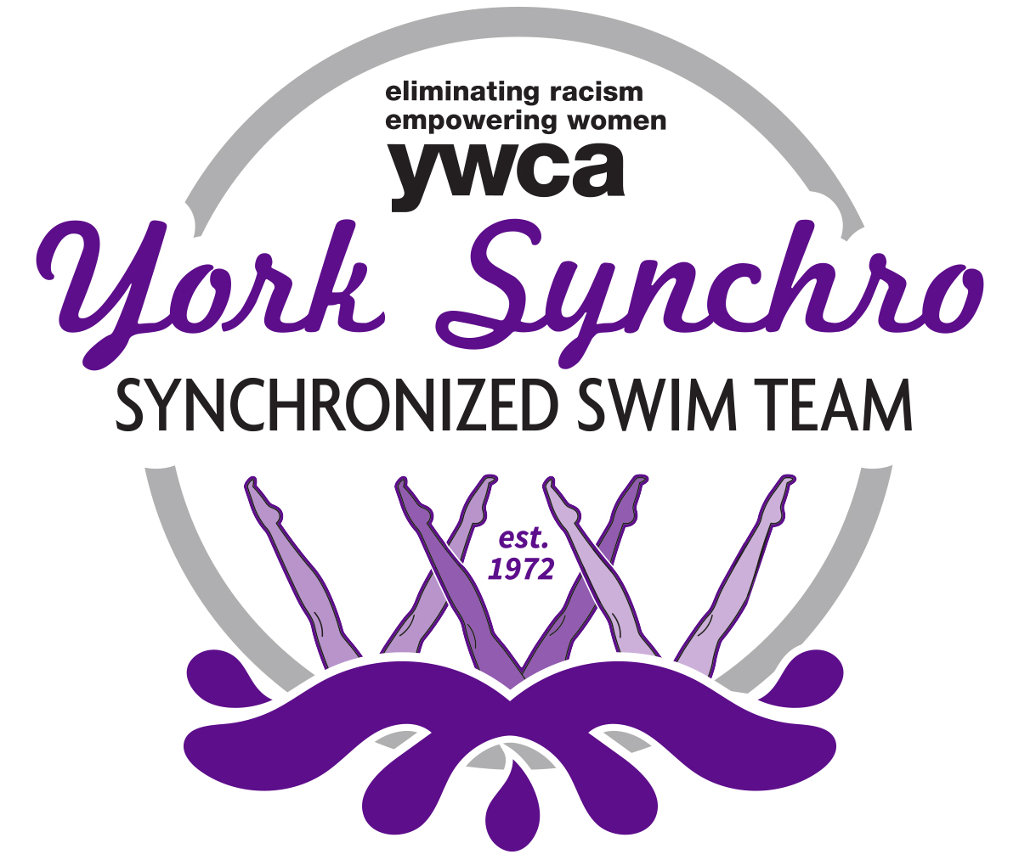

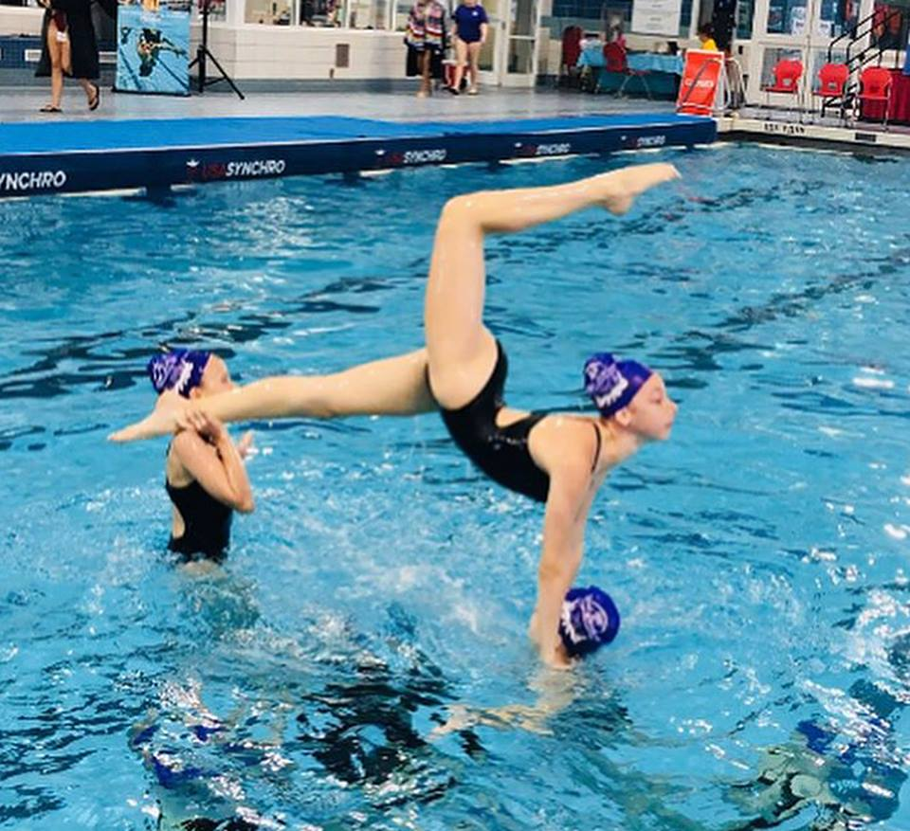

Calling All boys and girls in level 4 and higher to come to a FREE synchronized swimming clinic hosted by YWCA York Synchro. Participants must be able to swim alone in deep water and swim Front Crawl & Back Stroke one length of the pool. You will learn all of the basic synchro moves and put them together into a fun routine.